MyFlix API-Portfolio

Objective:
To build the server-side component of a “movies” web application. The web application will provide users with access to information about different movies, directors, and genres. Users will be able to sign up, update their personal information, and create a list of their favorite movies.

User Story :
As a user, I want to be able to receive information on movies, directors, and genres so that I can learn more about movies I’ve watched or am interested in.
Role:
As a developer my role was to create complete server-side of web application, including the server, business logic, and business layers of the application. It will consist of a well-designed REST API and architected database built using JavaScript, Node.js, Express, and MongoDB.
Tasks:
- Ensured that all domains are allowed to make requests to the API.
- Added data validations to users url.If entered data doesn’t meet the requirements, an error message will be sent as an HTTP response back to the client.
- Added three middleware modules, such as the body-parser package for reading data from requests and morgan for logging.
- Built Database using MongoDB
- Included user authentication and authorization code.
- The business logic is modeled with Mongoose
- Deployed API to Heroku hosting provider.

Decisions:
Used CORs to control which domains have access to API’s server ,thus can keep it protected from malicious entities.
Used a module called bcrypt to hash users’ passwords and compare hashed passwords every time users log in in order to ensure a more secure login authentication process.
Used express validator library to add validation to the application’s different types of inputted data.
Included authentication and authorization procedures,so no unauthorized entities should be able to make changes to the app or database.
Hosted API online on Heroku hosting provider

Github Link:
https://github.com/deepika-beep/MyFlix-app

Project Representation:
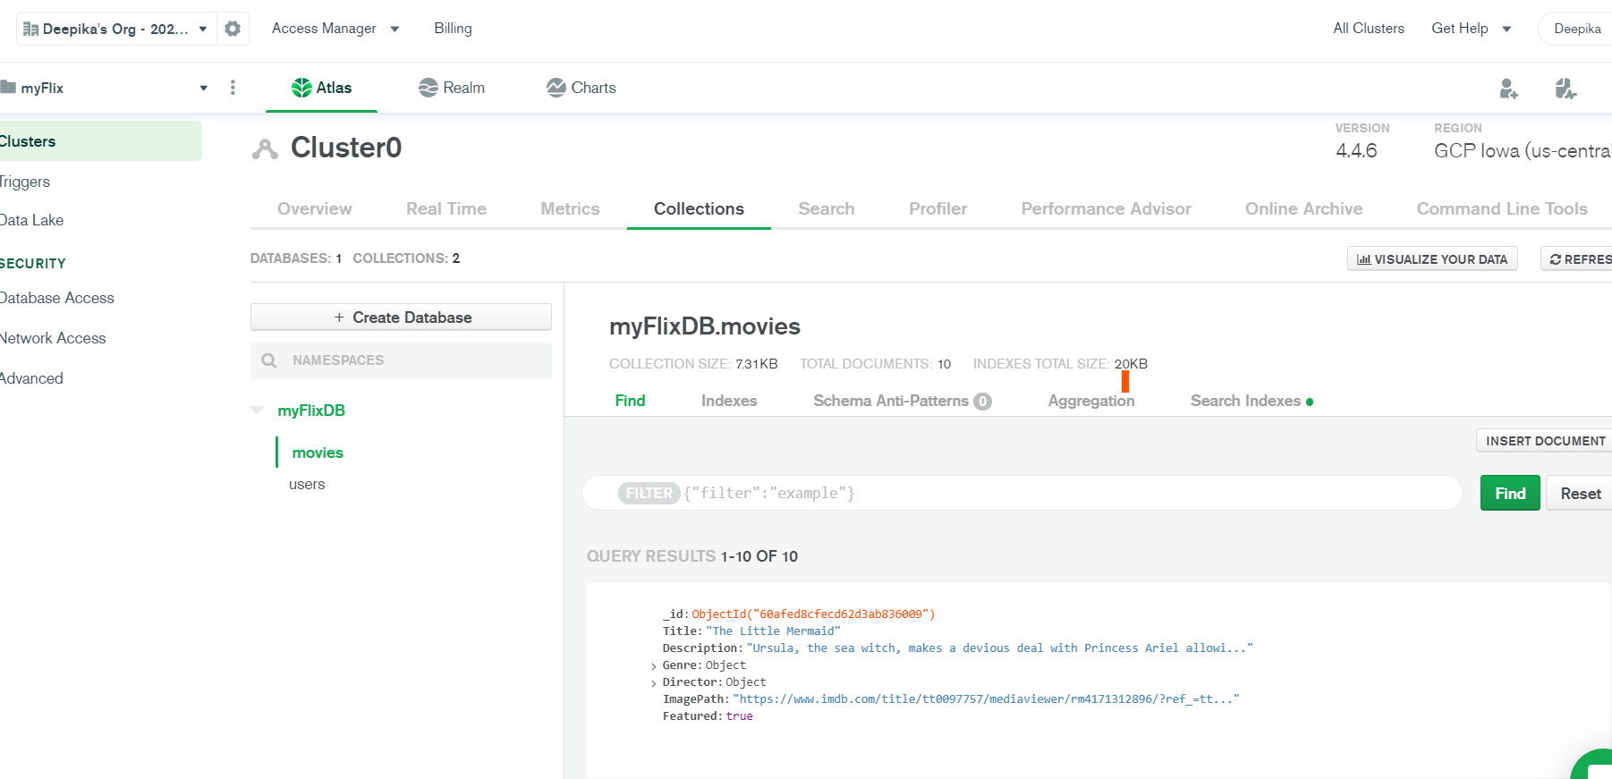

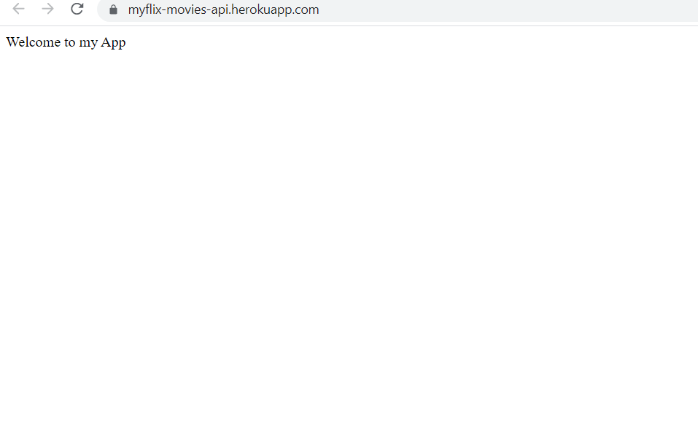
Project dependencies:

● NodeJs
● Express
● Mongoose

